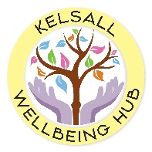
Coming Soon!
KELSALL WELLBEING HUB

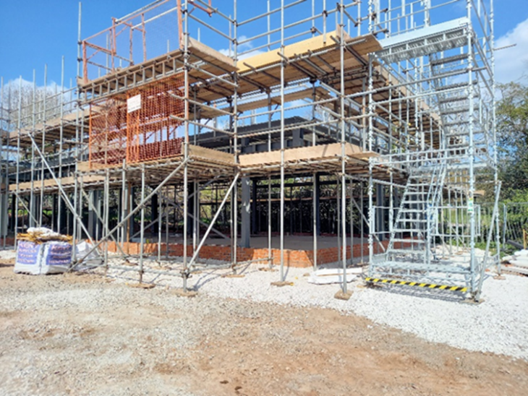
This will be a welcoming and friendly space for people of all ages to just drop in for a chat over a coffee or take part in a range of activities to enhance their mental and physical wellbeing. Adapting to life as a new parent, caring for a sick or elderly relative or being bullied at school? – The Hub is there to help.
Have you noticed the construction site for the new Medical Centre just off Chester Road and at the back of the village green?
Due to open in March 2022, the building also houses a unique community funded facility – The Wellbeing Hub.

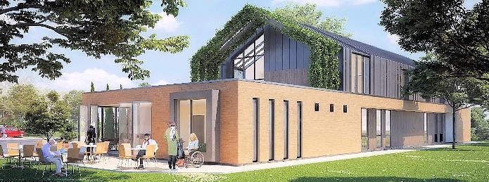
Please keep an eye on the noticeboards in surrounding villages or visit www.kelsallwellbeinghub.co.uk for more details on how to get involved, participate in events or join a fundraising activity.
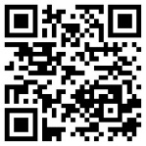
Keep up with The Hub

