Paid Election Volunteers Needed
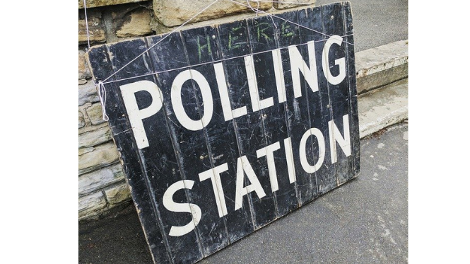

Local authorities are looking for paid volunteers to work at polling stations or counts for the elections which are taking place between 6 May - 10 May. Safe and secure polls are the cornerstone of our democracy and this is a great opportunity to support local elections teams to deliver COVID-secure and effective elections.

Please can you circulate the advert below with this survey link via your relevant distribution lists as soon as possible. The deadline to apply is midnight on Sunday 25th April.

Paid Election Volunteers Needed

Last year, various local elections and polls were postponed because of the ongoing coronavirus pandemic. They are now going ahead on 6 May 2021, and local authorities are looking for paid volunteers to fill a number of different roles between 6 May - 10 May. They need your help to make sure the polls can run in a COVID-secure and effective way - safe and secure elections are a cornerstone of democracy.

If you are over 18 and entitled to work in the UK you could be a:

- Poll Clerk - support the Presiding Officer who is responsible for the conduct of the ballot and making sure everyone who is entitled to vote is able to, without facing barriers or undue influence. Please only apply if you are available to work all day on Thursday 6 May. On the day of the poll, polling station staff should expect to need to be at their venue by just after 6am and to be on duty until around 10-11pm.

- Counting Assistant - employed to verify and count the votes cast at polling stations. Please only apply if you are available to work between 6 - 10 May. Hours required depend on the number of days of counting locally. They are typically around 6-7 hours on poll night (around 9pm-3/4am), and/or 6 to 7 hours on the Friday, Saturday, Sunday and/or Monday.

Pay offered will vary by role and local authority, but is likely to be between £135 and £250 per day.

The deadline for applications is midnight on Sunday 25th April. To find out more about the positions and to apply, please complete the Cabinet Office survey via this link.

Voting arrangements

If your application is successful, your nearby local authority may allocate you a role at a polling station which is different to the polling station you have been assigned to vote at on your poll card.

As you are required to remain at the polling station you are working at during the hours that the polls are open and the postal vote registration deadline has now passed, we would encourage you to apply for a proxy vote, whereby you can assign someone to vote on your behalf.

- To apply to vote by proxy you need to download, print and fill in the proxy vote application form. The deadline for applications to be received by your borough’s Electoral Registration Office is 5pm, Tuesday 27th April.

- You can deliver this form by post or by hand. Some local authorities also accept a scanned copy of your form by email. You can find the details of your local electoral services team via this link.

